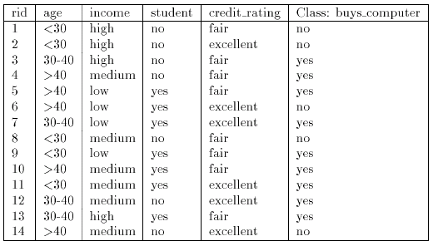

**The prior probability of each class can be computed as (For Student age <30)**

**The unknown sample:**

**X = {age ≤ 30, income = medium, student = yes, credit-rating = fair}**

**P(buy computer = yes) = 9/14 = 0.643 (Direct from Table)**

**P(buy_computer = no) = 5/14 = 0.357 (Direct from Table)**

